  2019 REBA Award Winning Initiative  Thursday 13th February 2020  Menopause bite-size  12.00-1.00pm in BWH 1.18  For men and women  Join the team for this lunchtime Bitesize training to learn about the Business case for raising awareness amongst all staff, guidance we have produced; find out about practical help, self-help and resources, and share information. Bring your lunch/drinks.  All staff and managers are welcome.  We particularly invite and would welcome attendance by male staff members!!  No need to book, JUST turn up!  Places are limited by room size. Please contact:  Maxine Benjamin, Maxine.benjamin@croydon.gov.uk  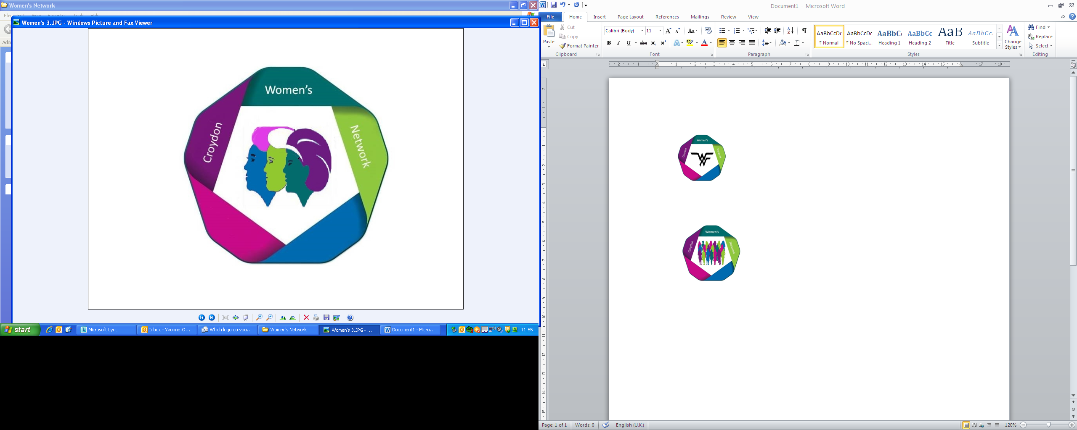  Debbie Bentley-Ross, Debbie.bentley-ross@croydon.gov.uk   | Help your staff, family or colleagues!  ────  What is the menopause?  signs & symptoms  ────  The business case  ────  Help available  ────  Practical support, self-help and resources  ────  Q&A  12.00-1.00pm  Bernard Wetherill House  Room 1.18

