


DOCUMENT CONTROL

The only controlled version of this document can be accessed on the Health and Safety Intranet site. Printed copies of this document, together with electronic copies held on local computers and other storage devices are uncontrolled.
Smoke Free

Framework

Corporate Health & Safety
Issue Date: September 2013

CONTENTS

Section 1 – Introduction |  | 1
1.0 | Purpose | 1
2.0 | Scope | 1
3.0 | References | 2
4.0 | Glossary of Terms | 2
5.0 | Revisions to this Document and Review | 3
6.0 | Summary of Changes in this Issue | 3
7.0 | Equalities Impact Assessment | 3
8.0 | Contact Details | 3
9.0 | Authorisations Details | 3

Section 2 – Arrangements |  | 4
1.0 | Statement | 4
2.0 | Aims of the Framework | 4
3.0 | Responsibilities | 5
4.0 | Planning and Implementation | 6
5.0 | Use of electronic cigarettes | 7
6.0 | Working in Service Users Homes | 7
7.0 | Residential Workers | 7
8.0 | Help for Smokers | 7
9.0 | Monitoring and Reviewing of Framework | 7

Section 3 – Related Documents | 8

Section 1 – Introduction
1.0 PURPOSE

- This policy framework sets out how the Council will meet its responsibilities as an employer under the smoke free provision in Part 1 of the Health Act 2006 and other relevant health and safety legislation to protect employees from the effects of smoking.

- This framework aims to protect employees from second hand smoke exposure, to use workplace restrictions to encourage employees to stop smoking, to demonstrate the Council’s commitment to its health leadership role and outline the Council’s provision for access to support.

  - SCOPE
2.1 The framework applies to Council commercial owned or operated buildings including the grounds within the perimeter of any Council workplace building.

2.2 The framework applies to:
(a) All employees of the Council;apprentices and volunteers
(b) All contractors including agency staff
(c) Elected Members
(d) All visitors to Council owned/leased/commercial buildings
(e) Council vehicles
(f) Employee owned vehicles when transporting service users, children and families.

  - REFERENCES
3.1 Statutory Instruments
- Health and Safety at Work etc. Act 1974
- Health Act 2006, Part 1

3.2 Approved Codes of Practice etc.:
- The Smoke-free (Premises and Enforcement) Regulations 2006
- The Smoke-free (Exemptions and Vehicles) Regulations 2007
- The Smoke-free (Penalties and Discounted Amounts) Regulations 2007
- The Smoke-free (Vehicle Operators and Penalty Notices) Regulations 2007
- The Smoke-free (Signs) Regulations 2007

3.3 Islington Council Arrangements/Guidance Notes
- Smoking Cessation

  - GLOSSARY OF TERMS USED IN THIS DOCUMENT
Term | Meaning
Workplace | All Council owned/leased/commercial buildings or vehicles.
Contractors | Employees of a company that supplies a service or services to the Council
Other employee | Employees of other companies who visit Council owned or operated buildings e.g. delivery drivers, inspectors etc.
Premises | All Council owned or operated work buildings
Enclosed premises | Premises which have a ceiling or roof and (except for doors, windows or passageways) are wholly enclosed either on a permanent or temporary basis.
Line Manager | Person with direct responsibility for staff e.g. Supervisor, Team Leader, Head of Service, Service Manager etc.
CH&S | Corporate Health and Safety (competent team employed to assist the Council in undertaking the measures it needs to take to comply with the requirements and prohibitions imposed upon the Council under the relevant statutory provisions).
Suitable and sufficient | A risk assessment that is carried out with enough detail to deal with the degree of risk involved.

  - REVISIONS TO THIS DOCUMENT AND REVIEW
  - These arrangements will be updated when necessary by distribution of a complete replacement.

  - Amended or additional parts of revised pages of this document will be marked by a vertical black line in the right hand margin.

  - Corporate Health and Safety arrangements (frameworks) will be reviewed at intervals of not more than thirty-six months.

  - SUMMARY OF CHANGES IN THIS ISSUE
Section | Summary of Change
N/A | N/A
  - EQUALITIES IMPACT ASSESSMENT
Part 1 – Initial Screening undertaken on 17th June 2012
Part 2 – Full impact assessment not undertaken as not required

If readers require a hard copy of the document in large print then please contact Corporate Health and Safety.
  - CONTACT DETAILS
For more information or in the event of inquiries, please contact Corporate Health and Safety (CH&S)

Tel. 020 7527 2230
E-mail. donna.lewis@islington.gov.uk
  - AUTHORISATION DETAILS
Author | Authorised by
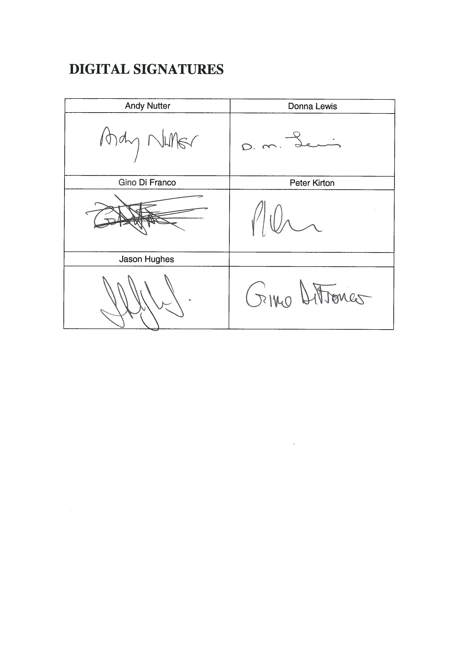  Donna Lewis  Corporate H&S Adviser | Andy Nutter  H&S Management Representative  Chair of the Joint Executive H&S Committee
Date: September 2013 | Date: September 2013

Section 2 – Arrangement
1.0 STATEMENT
1.1 The adverse effects to the health of those who smoke have been universally accepted by the medical profession. Lung cancer, heart disease, asthma, bronchitis and pneumonia are considered the most well know results of smoking. Medical evidence has also proved that passive smoking as a result of inhaling other people’s smoke is just as harmful.
1.2 The Council has a statutory and common law duty to provide a safe and healthy working environment for all its employees.
1.3 From 1 July 2007 all enclosed public places and workplaces in England including schools and vehicles are required to be smoke free.
1.4 The smoke free law is enforced by local Councils within the areas which they have responsibilities.
1.5 The enforcement approach of the Council will be by providing advice, support and information in the first instance.
1.6 Formal enforcement action should only be needed when the seriousness of the breaches in law warrant such action
1.7 However non compliance with the smoke free law is a criminal offence and the fixed penalty notices and maximum fine for each offence set down by the legislation are as follows:
- Smoking in smoke free premises or work vehicles – a fixed penalty notice of £50 imposed on the person smoking, or a maximum fine of £200 if prosecuted and convicted by a court.
- Failure to display no-smoking signs – a fixed penalty of £200 imposed on whoever manages or occupies the smoke free premises or vehicle, or a maximum fine of £1000 if prosecuted and convicted by a court.
- Failing to prevent smoking in a smoke free place – a maximum fine of £2500 imposed on whoever manages or controls the smoke free premises or vehicle if prosecuted and convicted by a court. There is no fixed penalty notice for this offence.
1.8 If an employee breaks the law consideration must be given to disciplinary action.
1.9 Facilities will not be provided for smokers within the immediate vicinities of Council workplace buildings except for external cigarette disposal bins for clients use where required.
2.0 AIMS OF THE FRAMEWORK
2.1 The aim of this framework is:
- To ensure that the Council complies with Part 1 of the Health Act 2006 and relevant codes of practice as outlined above.
- To enable the Council to be totally smoke free in all Council owned/leased buildings and all leisure/recreational facilities.
- To promote a healthy environment, which protects employees and visiting public from the effects of passive smoke
- To reduce if possible, and control risks in relation to work as far as reasonably practicable.
- To raise awareness of the dangers associated with exposure to tobacco smoke
2.2 The Council’s smoke free framework is integral to its approach to staff health, welfare, and well being. It aims to protect and promote the mental and physical health of employees at work.
3.0 RESPONSIBILITIES
3.1 Managers have the following responsibility for:
3.1.1 Ensuring all employees comply with the requirements of this framework.
3.1.2 Undertake appropriate and necessary action to protect non-smokers from breathing second hand smoke.
3.1.3 To advise employees of smoking cessation options
3.1.4 Include monitoring of the framework in health and safety inspections.
3.1.5 To ensure that all council leased/owned vehicles have a no smoking sign displayed in each enclosed compartment that can accommodate people.
3.2 Premises managers have responsibility for:
3.2.1 For ensuring that standard signage is in place at all times.
3.3 Employees have responsibility for:
3.3.1 To comply with this framework and report any breaches to their line manager.
3.3.2 To take reasonable care for the health and safety of themselves and of others who may be affected by their acts or omissions at work.
3.3.3 Co-operate and comply with the smoke free framework and with any arrangements introduced/actions taken to protect non smokers in the workplace.
4.0 PLANNING AND IMPLEMENTATION

4.1 All Council owned/leased premises and vehicles shall be designated as smoke free with standard signage. (See appendix 1)

4.2 Smoking will be prohibited in any ‘enclosed’ or ‘substantially enclosed’ Council owned leased/premises. This includes:
- Lifts  - Corridors  - Stairways  - Rest rooms  - Refreshment areas  - Meeting rooms  - Toilets  - Libraries  - Residential establishments | - Reception areas  - Entrances/exits to Council premises  - Shelters/sheds or similar structures  - Community centres  - Day centres  - Leisure centres  - Vehicles
  - In addition any ‘open air’ Council owned/leased premises shall be designated as smoke free e.g. Council car parks that are not designated as a public car park.
  - The framework will cover all leisure and recreational facilities, (but not open spaces such as parks and gardens) under its control to be totally smoke free. Tobacco products are not permitted to be sold at any retail outlet within these premises.
  - Employees must not smoke anywhere in public view whilst wearing Council identify badges and/or marked clothing.
  - Employees must also give consideration to not smoking in sight of or in the proximity to children and their play areas.
  - Employees must also give consideration to not smoking adjacent to health premises such as GP surgeries etc.
  - The framework requires that employees must not smoke on the street or within 50 metres of the perimeter of a council building. (N.B It is recognised that the prohibition on smoking within the perimeter of a building cannot be enforced against visitors who are not Council or other employees).
  - Persistent breaches of this framework exposing others to the dangers of second hand (passive) smoke will be handled through the normal disciplinary procedure.
  - Employees will not be granted extra breaks from work in order to smoke. Members of staff who wish to smoke must adhere to the framework and utilise their regular permitted breaks.
  - There is no requirement under the legislation for outdoor smoking shelters to be provided for employees or members of the public and as such the Council will not provide this facility.
  - Employees who use their own vehicles whilst on duty are able to smoke in their private vehicles except on days when they have scheduled journeys with other employees, service-users, and/or elected members.
5.0 USE OF ELECTRONIC CIGARETTES
5.1 Electronic cigarettes (e-cigarettes) are battery-powered products that release a visible vapour that contains liquid nicotine that is inhaled by the user. E-cigarettes fall outside the scope of the smoke-free legislation however Islington Council have decided that e-cigarettes are banned within 50 metres of the perimeter of any council building and the framework will cover all council work, rest and common areas, entrances, exits and council vehicles.
5.2 The e-cigarettes are banned within Islington due to:
5.2.1 Insufficient evidence in relation to the health risks that they may pose to individuals using them and those in close proximity
5.2.2 Research show that e-cigarettes affect smoke detectors particularly ionizing smoke detectors
5.2.3 E-cigarettes look like real cigarettes particularly from a distance which makes a smoking ban difficult to enforce and creating an impression for visitors, customers or other employees that it is acceptable to smoke.

6.0 WORKING IN SERVICE USERS HOMES
6.1 It is recognised that staff who visit and/or provide services to people in their own homes may be at risk if the person being visited is a smoker as private homes are not covered by the Health Act 2006.
6.2 A practical approach should be taken to the management of such circumstances to provide a balance between respecting the rights and needs of service users and the safety and welfare of employees.
6.3 Smoking by employees in client homes and workplaces managed by outside organisations is not permitted.
Note: See section 11 of the Manager’s Guide for further details on managing the risk in service users’ homes.
7.0 RESIDENTIAL WORKERS
7.1 Where an employee’s place of work is also their temporary living area, e.g. a residential care worker, smoking will not be permitted.
7.2 Where the council own residential buildings the smoke free framework should be implemented, however if the building has been leased then smoking shelters may have been provided by the landlord for tenants use.
8.0 HELP FOR SMOKERS
8.1 This framework recognises the right of the individual to smoke, however to help individuals who wish to give up smoking a number of support mechanisms have been put in place:
- Access to smoking cessation support groups;
- Access to drop in centre in Islington;
- Access to the Employee Assistance Programme;
- For further information visit ‘Islington Stop Smoking Services’ on the following links http://www.smokefreeislington.nhs.uk and
http://izzi/council/councilnews/freetime/health/Pages/Smoking.aspx
9.0 MONITORING AND REVIEWING OF THE FRAMEWORK
9.1 Managers should ensure that they include the monitoring of the smoke free framework in health and safety inspections and management assessments.
9.2 Corporate Health and Safety and Human Resources will keep under review the application of this framework and its compliance with statutory requirements.

Section 3 – Related Documents
- Smoke Free, A Guide for Managers
- Smoke Free, A Guide for Employees

