Redeployment Guide

Introduction

In order to find suitable alternative employment for staff displaced as a result of redundancy the Council will be pro-actively managing redeployment. Redeployment is the responsibility of managers and the redeployee, who will be assisted by Human Resources (HR).

Redeployees may find the Redundancy Information Guide useful as it provides guidance of their rights in the event of being made redundant and support available. Use the link to access this document which is also available on Enfield Eye.

Roles in the Redeployment Process

Human Resources

HR will be responsible for providing active support to redeployees seeking redeployment by:

- providing on-line access to all Council vacancies in advance of them being advertised internally and externally
- proactively matching redeployees (where applicable) with vacant posts.

A HR representative will be allocated to redeployees to assist them in securing alternative employment with the Council.

The Exporting Manager

The exporting manager, (the manager responsible for the redeployee) at the time they are identified as potentially redundant), will be responsible for actively supporting the redeployee through the redeployment process.

The exporting manager will also be responsible for completing part 2 of the “Redeployment Skills & Competency Assessment form” (please see Appendix 1), and returning it on an urgent basis to HR as the information will be used to match redeployees to vacant positions.

The exporting manager should also ensure that they act in the best interests of the redeployee throughout the redeployment process.

The redeployee remains the responsibility of the exporting manager until they are either successfully redeployed or leaves the Council as a result of redundancy.

The Importing Manager

The importing manager, (the manager of a vacant position to which a redeployee has been matched or has applied) also referred to as the recruiting manager, must fully engage in this process and will be responsible for supporting and encouraging the redeployee during any trial period, identifying any issues and/or needs that the redeployee may have and addressing them to maximise the successful redeployment of the redeployee.

The importing manager will be expected to quickly identify and address appropriate training needs/other issues the redeployee may have in support of their assignment. They will also be expected to support the redeployee through the process. This may also involve dealing with issues/queries regarding the redeployee from the existing employees to ensure the redeployee’s successful integration into the team.

The Redeployee

The redeployee must fully and actively engage in the process in order to maximise their potential for seeking permanent alternative employment. A refusal to participate may result in the redeployee not receiving a redundancy compensation payment.

Redeployment Register

Human Resources will be responsible for developing and maintaining the Redeployment Register.

Eligible staff will be placed on the Redeployment Register for a maximum period of four months, except where this period is extended to allow a redeployee to complete his / her trial period or where an employee’s redundancy notification has not yet expired.

Redeployees will be given a log in/password to the Redeployment Recruitment Site. (Appendix 2)

The Redeployment Job Site will enable the redeployee to apply for jobs, sign up for e-mail job alerts and manage their own applications. Vacancy information will be uploaded weekly by 4pm each Thursday and remain open for two weeks till midnight on the closing date, this being open for any redeployee to apply using the on-line application; giving the redeployee two weeks to apply.

Employee Responsibilities:
Employees on the Redeployment Register are responsible for actively seeking suitable alternative employment, and the following actions:

- provide information requested or required within prescribed timescales
- apply for a post if he / she is interested in a vacant position
- to co-operate fully in any assessment and interview processes
- exercise flexibility in relation to potential alternative posts, taking into account their personal circumstances, and the likelihood of other suitable post(s) arising
- to detail how their skills and abilities meet the criteria of the vacancy as specified in the person specification

Vacant Posts

Details of all eligible posts (3 months or more duration) must be notified to HR. This includes posts that are to be recruited either for the Council directly or via an agency. Please see the Principles of Internal Resourcing for further information.

When an eligible post becomes vacant, the manager of that vacancy should notify HR. This vacancy will need to go through the redeployment process before it can be advertised.

Matching

Matching only applies to employees who have been displaced as a result of a restructure and/or are at risk of redundancy (in receipt of an at risk letter). Please see Appendix 3 for a full list of categories where matching will apply.

HR will review the vacant posts on a weekly basis to consider whether or not there is justification for a ‘match’ between the redeployee(s) and the vacant position(s).

When considering whether a ‘match’ is justified, HR will consider:

- is there a sufficiently clear and significant similarity between the skills / experience and ability of the redeployee and the requirements of the post?
- where the redeployee / post comes from different disciplines and/or ‘professions’, are the redeployee’s skills reasonably transferable?
- whether any gaps in the redeployee’s skills / experience are of a minimal impact and/or could be addressed by reasonable training during the trial period?

Redeployees eligible for matching will complete a Redeployment Skills & Competency Assessment Form containing details of the skills, knowledge, experience and competencies gained in current and previous employment. The redeployee’s manager will write the reference for the redeployee on part two of this form.

The decision as to whether a ‘match’ is justified will be based on the information provided in the Redeployment Skills & Competency Assessment Form and a Competency assessment. Further details of the competency assessment can be found in the Staff Competencies available on Enfield Eye

These assessments will utilise the Council’s competency sets and allow redeployees to identify that the levels of competencies attained may be transferable to other positions in the Council thereby increasing their career opportunities and minimising redundancies.

Where a redeployee is matched to a vacant post HR will contact the recruiting manager to inform of the match. An assignment meeting will be arranged between the recruiting manager and matched redeployee to discuss the performance objectives and determine whether there are any training and development needs.

Skills assessments
In some instances the manager may consider that a skill assessment is required prior to the trial period commencing. HR will arrange a meeting with the recruiting manager to discuss the ‘match’ and the most appropriate form of skills assessment. The success criteria will be agreed at the outset and the redeployee will be advised of this, by HR, before he / she takes the skills assessment.

If the redeployee meets the success criteria he / she will undertake a ‘trial period’ in the new role for an initial period of 6 weeks. At the end of the trial period the recruiting manager can either contact HR - to confirm the redeployee in the new post (confirmation of appointment letter) or extend the trial for a further period of up to 6 weeks.

Where it is determined that a skills assessment is not required the redeployee will commence the trial once he / she is matched to the post.

Multiple Matching
If more than one redeployee is initially identified as a potential match to a vacancy, all matched redeployees will be put forward for a placement discussion. The Manager will then select the redeployee best suited to that post. The manager must be able to justify this decision. The placement discussion is an interview, conducted in accordance with the Council’s Recruitment and Selection Policy and Procedure, to decide which redeployee is best suited for the post.

Redeployment – Trial Periods

The purpose of a trial period is for both the recruiting manager and redeployee to assess the suitability of the appointment. Trial periods will normally run for 6 weeks. However, the trial period can be extended by the manager for a further 6 week period for the purposes of, for example, retraining the redeployee. This means a maximum trial period of up to 12 weeks.

Where applicable if the trial period extends beyond the redeployee’s redundancy date, then the redundancy date will be extended pending the outcome of the trial period.

The recruiting manager should advise the redeployee to keep leave requests to a minimum during the trial period.

As the recruiting manager you need to Induct and Review regularly the redeployees performance.

Further information and documents for completion with your new member of staff can be found at the Managers Guide to Inducting and 1-2-1 Reviews for Redeployee.

Towards the end of the trial period the recruiting manager should contact HR to confirm whether or not the trial period has been successful. Completing the Trial/development period final assessment report, if it has been successful, HR will prepare and issue a confirmation of appointment letter and contract of employment.

The redeployee will not be entitled to continue to access and apply for positions via the redeployment process while they are on a trial period. Should the trial period prove unsuccessful for any reason, redeployment access will resume until such time of the redundancy date. Access to jobs on the redeployment recruitment site will cease on the employee’s redundancy date. Where a redeployee’s redundancy date is extended access to the redeployment recruitment site will also be extended until the redundancy date.

Pay during Trial Periods
Redeployees will be paid at their substantive rate of pay during a trial period. If the trial is successful the redeployee will receive the rate of pay for the vacant post, from the date that he / she is confirmed in post.

The department that currently employs the redeployee will be responsible for the redeployee’s pay during a trial period. Once a redeployee is confirmed in post the department (where the vacant post existed) will become responsible for the individual’s pay.

Unsuccessful Trial Periods
If the manager decides that the trial period has not been successful, then he / she will need to contact HR and provide them with details of why they consider the redeployee to be unsuitable for the job role. This will be reviewed by the Assistant Director of Human Resources.

If the redeployee is not suitable for the post Human Resources will liaise directly with the redeployee to outline the next steps in terms of their employment with the Council.

Where an employee is made redundant following an unsuccessful trial period, the department that deleted the redeployee’s original post (where the employee was originally employed) will be responsible for the redundancy and associated costs.

Applying for Vacant Position on the Redeployment Site

All redeployees may apply for any vacant position advertised on the redeployment recruitment site. The on-line application must be submitted by the closing date as stated on the Redeployment site. It is important to note that all applications will be held pending the outcome of a matching - skills assessment. If the vacant post is not subject to a match, then the application will be progressed in the normal way.

If the recruiting manager decides that an application made by a redeployee meets the essential criteria on the person specification for the vacant post, they will contact the redeployee directly to arrange an interview. This should be a formal interview in line with the Council’s Recruitment and Selection Policy and Procedure.

The exporting manager needs to be flexible, fully support the redeployee and ensure that they are given time off to attend any interviews they have secured through this process.

If the manager decides that an application by a redeployee does not meet the essential criteria for the post, they will be informed by email and offered feedback by the manager.

Where an application made by the redeployee is successful the recruiting manager will inform the individual of the interview outcome. HR should also be informed so that they can send out the offer letter to the successful redeployee applicant.

Redeployment Help and Support
There are numerous support measures available for help through redeployment. Below is an outline of these:
The council offers ‘The Employees Assistance Programme’ (EAP) which is a free and confidential service available to staff. To contact the service simply phone 0800 282 193. The service is available 24 hours a day, 7 days a week. Alternatively, for online advice and information for all employees (e.g. nutrition, a healthy heart, money matters) log onto http://www.ppconline.info/ and enter the organisational password and ID:
Username: Enfield
Password: Council
The council is working with Global Solution Services (GSS) who are a Department of Work and Pensions approved and funded provider for 'Job Search Support services for professionals'. Whether you are looking for positions internally or externally it is vital that you have a good understanding of the interview processes and the importance of knowing how to effectively deal with questions, panel interviews, and Assessment centres. Below is an overview of this 1 day workshop support available for staff on the redeployment Register
Staff potentially being displaced: support on offer

1day workshop with follow on 1-1 session including:
- Understanding the current job market
- How to effectively job search
- CV preparation advice and guidance
- Interview skills including competencies and Psychometric examples
- Competency interviewing and Successfully preparing for interviews
- Knowledge of different interview types
- Working with social media agencies and job boards
- Individual CV Review
- Considering further training opportunities

Staff when displaced: support on offer

- Completion of Redeployment Skills and Competency Assessment Form
- Psychometric assessment - shows strengths against corporate competencies
- Job matching
- Further 1-1 with redeployment officer – training given to address gaps if any identified
- Should a role be offered, a trial period
If you have any queries about redeployment, or applying on-line, please e-mail cheryl.ponnou@enfield.gov.uk contact number is 0208 379 4237 or contact a member of the HR team.

Appendix 1 - Redeployment Skills & Competency Assessment Form
Part 1 Redeployee to complete:
This form will allow HR to gather more information about you in order to help assess your suitability to roles, should the ‘matching’ principle be relevant to you.

Name:

Dept:

Service:

Job Title:
Hours per Week:
Grade:

Work email address: (Please tick which email
you would prefer)

Home email address:

Brief outline of current duties & responsibilities:

Competency self assessment:
(Please complete and hand in at your staff support workshop), ticking one box for each competency. Please see the Council’s competency framework for further information.

Please complete boxes highlighted in blue if your current role is graded MM1 or above.
 | Highly Effective | Effective | Development Needed
Self Control
Integrity & Self-knowledge
Planning & Organising
Working in Partnership
Achieving Excellence
Customer & Community Focus
Change
Shaping strategic direction
Inspiring and leading change through people
Intellectual adaptability
Political awareness
Taking initiative/seizing opportunity

Previous Experience:
(Please state below your previous roles in/outside of the Council within last 5 years, continuing on a separate sheet attached if necessary).

Previous Post Title:
Dept: Dates to/from:
Brief outline of duties/responsibilities:

Any additional skills/experience/abilities that may be of interest, e.g. qualifications, language skills:

Please note: When applying for a vacancy via redeployment, you will be required to complete a full application which will allow you to enter more information about yourself.

Additional Comments: Please insert any additional information which you would like HR to take into consideration when matching you to other job roles, such as your preferences, a disability or illness which may prevent you from working in certain areas of the Council or caring responsibilities which may prevent you from working evenings/weekends.

Declaration:

I confirm that, to the best of my knowledge, the above represents an accurate reflection of my skills, competencies and experience.

Employee signature: Date:

(An electronic signature is acceptable).

Please pass this form to your manager to complete Part 2.

Managers Report

Part 2 - Manager to complete

IMPORTANT - please fully complete this form and state “not applicable” where necessary

1. General Information

Dates of employment within team/section: | From To
Job title:
Purpose of Job Role:
Main duties:
2. Assessment of Competencies: please comment on the individual’s overall competencies:- (for further information regarding the Council’s competency framework, please click here
Please complete boxes highlighted in blue if the individual’s role was graded MM1 or above.
 | Highly Effective | Effective |  | Development Needed
Self control
Integrity & Self-knowledge
Planning & Organising
Working in Partnership
Achieving Excellence
Customer & Community Focus
Change
Shaping strategic direction
Inspiring and leading change through people
Intellectual adaptability
Political awareness
Taking initiative/seizing opportunity
- Additional Information

Number of sickness absent days in the last 12 months

Are/were there any disciplinary warnings recorded in respect of the applicant which are not expired  If yes, please state reasons for warnings and dates given |  |  | Yes No
Is/was any disciplinary action pending against the applicant (including whether or not the applicant is currently the subject of a disciplinary investigation)?  If yes, please give details |  |  | Yes No
Is/was any disciplinary action pending against the applicant in relation to child/vulnerable adults protection issues/(including whether or not the applicant is currently the subject of a disciplinary investigation)?  If yes, please give details |  |  | Yes No
4. Declaration

I confirm the answers I have given are correct to the best of my knowledge and belief.

Name:
(IN CAPS)

Signature: Date:

(An electronic signature is acceptable).

Relationship to applicant:

Contact Tel: for enquiries about this reference

Please note that this is document is not confidential as we operate an ‘open file’ policy.

Please email this form (with both parts 1 & 2 completed) to the HR Business Advisor managing the redeployment of this employee so that the information may be used to find suitable alternative employment.

Matching the redeployee to other posts cannot begin until this completed form has been received by HR.

HR Section

Part 3 HR to Complete

Redeployment category:

Assessment details:

Psychometric assessment scores:

Appendix 2 - Redeployment Site User Guide

Introduction

To access the Council’s electronic redeployment site:
1. Click on workforce on the Enfield eye (orange tab at the top of the page)
2. Scroll down to recruitment and click on current vacancies. This will open the Council’s internal vacancy site.
3. Select redeployment vacancies from the left list. You will then be asked to log in.

Alternatively, you can access the site at this address:
http://www2.i-grasp.com/fe/tpl_enfield03.asp

In order to access the Redeployment web site you must have a Username and password, the general setting for these is below. If we need to set you up with a different username to this format, we will contact you.

Username: your work e-mail address
Password: spring

It would be worth you taking a few moments to check you are able to log in OK, the screen you should see after entering your Username and Password is below. As explained on the screen, please do not upload your CV/Work history via this first screen, you will not need to do this until you apply for your first vacancy.

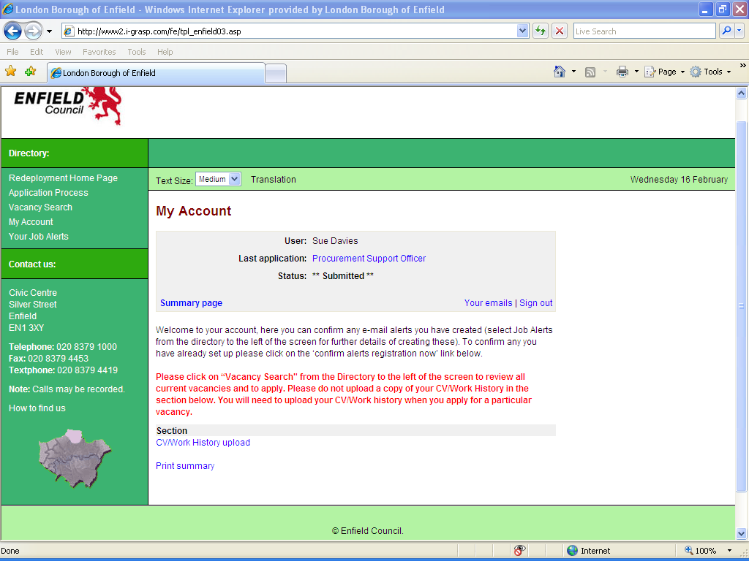
If you have any problems with any aspect of the redeployment process, please contact:
Cheryl Ponnou Redeployment Officer Human Resources:

Tel: 020 8379 4237
Email: cheryl.ponnou@enfield.gov.uk

Please note access to a computer and the internet can be gained from any local library if you do not have these facilities at home or at work. Please contact your local library for further details.

How to search and apply for vacancies

Click on vacancy search from the left side menu and click search and apply to see all vacancies. Select the vacancy that is of interest to see further details including the role profile and person specification. You can then click on apply if you wish to complete an on-line application.

Please complete each of the required sections, click to submit your on-line application and you will receive a confirmation email. There are instructions on the screen as you complete the different sections of your application that will guide you through. If your application is shortlisted, we will call you or you will receive an email inviting you to book an interview slot. If your application is unsuccessful, we will email to inform you.

Full details on how to apply for vacancies can be found by selecting the application process option from the left side menu.

Once you have made your first application, the system will store all your details so that for subsequent applications, you should only need to address the application questions that are unique to each vacancy.

Register for job alerts

This facility allows you to select a vacancy criterion that interests you so that you will receive an email alert when a vacancy appears on the redeployment site that relates to the desired criteria. Please note however that we strongly advise you do not define any vacancy criteria as this may mean you could miss seeing any other vacancies that week that could also interest you.

How to change your password / e-mail address

When you make your first application for a vacancy, click on the main details section and then click to modify your log in details. In this section you can then change your password details.

You can also change the e-mail address that we will contact you at in this section should you wish.

The system has been set so that we will contact you at your work e-mail address. Please note; if you change your e-mail address via the main details section, your username will also change to that new e-mail.

Appendix 3 - Redeployee Categories

Employees will be included in the Redeployment Process in line with the following categories:

Category 1 – a permanent employee under notice of Redundancy, or at risk of Redundancy (e.g. where notice has not yet been served).

1a) Potentially Redundant – displaced from current post and/or under notice of redundancy:
Matching will normally apply to all such cases. For Matching not to apply, this must be authorised by the Assistant Director of HR whose decision will be final.

1b) At Risk of Redundancy – but notice has not yet been served:
Matching will not normally apply in these cases since these employees may not ultimately receive notice of redundancy. However, where compelling reasons exist and in exceptional cases, the HR Department, in conjunction with the relevant Manager, will consider allowing a Category 2 Redeployee to be subject to Matching. The decision on this matter will rest with the Assistant Director of HR and the decision will be final.

Category 2 - a temporary employee or an employee on a fixed term-contract that is ending, and who has more than 1 year’s service.

2a) Temporary employee on a fixed term-contract whose contract is ending and has more than 2 years continuous service:
Once the end date has been identified staff will be subject to matching.

2b) Temporary staff or employees on a fixed term-contract with 1 year's service but less than 2:
There staff will not be subject to the Matching Process because they are not permanent employees of the Council and do not have underlying entitlement to a redundancy payment. Our obligations to our permanent staff take precedence.

Category 3 – unable to undertake their contractual duties as she / he has developed or has a disability as defined Equality Act 2010.

These are employees who are permanently unfit to undertake their own job due to a disability but who may be able to be redeployed to another post, and will be subject to the Matching Process.

Category 4 – unable to undertake their contractual duties for medical reasons but are otherwise fit to work.

These are employees who are permanently unfit to undertake their own job but who may be able to be redeployed to another post. These employees will not be subject to the Matching Process.

Category 5 – Returning from career break.
Placed on redeployment for a period of 3 months. Not subject to matching.
This category only applies to career breaks that started prior to 1 August 2010.

Category 1, 2, and 4 employees will only remain on the Redeployment register for a period of up to 4 months only. The Assistant Director of HR can extend this period or a HR manager duly authorised by the AD, in exceptional circumstances.

