**InfiniStats Guide for New-Users**

**2025**

**Your account**

Once your council’s superuser has created your account, you will receive an email from [support@infinistats.com](mailto:support@infinistats.com) with a link to set your password and complete the setup of your account. You will then be able to login to your account.

**Logging in to InfiniStats**

You can log in at [www.infinistats.com](http://www.infinistats.com)

The front page comes up first (there is information about InfiniStats on the front page - you don’t need to login to see this - just scroll down.)

To log in click on  in the top right of the front page.

Log in using your email address and password (you’ll be asked to set this up the first time you log in). If you are a multiple-council user you will be asked to choose which council you want to log into.

If you forget your password you can reset it by clicking on the ? to the right of the sign in box on the login page.

Once logged in you will have access to surveys, on a survey by survey basis and may have read, or read/write access to each survey. This access to surveys is set up and controlled by your council’s Superuser (nominated by the Council’s Head of HR) who maintains the user permissions and access for users in their own council.

Councils’ Superusers are set up on InfiniStats by their Organisation Admin (based in their Regional body).

**First Screen – List of surveys**

Once you’ve logged in, the first screen you’ll see lists the surveys. Click on the survey you want to see/add data to/access results for.

Apart from Pulse and User Surveys (covered at the end of this guide) the surveys fall into two main types:

1. Data is uploaded on an Excel template questionnaire (eg: Pay Surveys)
2. Data is entered on an online form (eg: Human Capital Metrics Survey)

The list of surveys you see, depending on your access permissions might include:

* **Pulse & User Surveys** – A way for you to set up and conduct your own surveys to be asked of other users. They respond online.
* **Chief Officer Pay & Benefits** – collects data on Chief Officer roles by Occupation type (eg: Finance, HR etc.) and by tier (A1=CE, A2=reports to CE, A3=reports to A2). Input data by uploading Excel questionnaire.
* **Gender Pay Gap** – InfiniStats will enter the Gov.uk data for you
* **Human Capital Metrics** –this covers the permanent workforce (excluding schools’ & Fire Service employees) and collects data on Headcount and FTE, diversity, length of service, sickness and leavers/turnover. Input data on an online form.
* **Pay & Benefits** (Excl Social Workers) – covers a set of roles by level (I to IV) and includes recruitment and retention difficulty. Input data by uploading Excel questionnaire.
* **Pay & Benefits** (Social Workers) – covers a set of Social Worker roles and includes recruitment and retention difficulty. Input data by uploading Excel questionnaire.

To enter data or to generate results, click on the survey you want and the options will appear.

**Type 1 Surveys (Excel Questionnaire Upload) – e.g. Pay Surveys**

For the two Pay & Benefits Surveys (1. Excl Social Workers; and 2. Social Workers) and the Chief Officer Pay & Benefits survey you upload data on an Excel questionnaire (it’s important you do not alter the layout or format of the Excel Questionnaire, other than completing it with your data).

The steps in the process are:

* get the Excel questionnaire - these are available on Downloads (upper right of screen relevant pay survey page)
* fill in your data on the Excel questionnaire and save it to your drive
* log into InfiniStats
* click on the relevant Pay Survey (Pay & Benefits Social Worker, Pay & Benefits (Excl. Social Workers), or Chief Officer Pay & Benefits)
* click on Input/Edit data
* select the period (data as at 1 April each year) and click on Bulk Upload Data
* click on Choose File and select your Excel questionnaire from your files
* click on Next Step

At this point InfiniStats will either:

* show you the data on screen for you to check before clicking on Save see screenshot below; or
* give you a reason it cannot be uploaded (so you can click Back to correct your upload file before trying again).

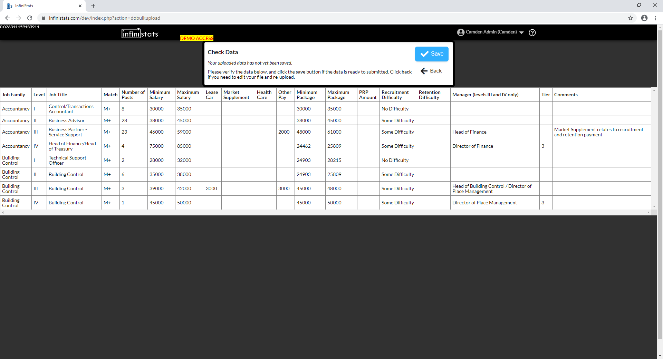

There are also some other surveys that may be added later that work with Excel questionnaire uploads. These include Terms and Conditions and Trade Union Membership & Paid Officials surveys which provide custom-built Excel Results in the form of tables that show a compilation of all responses for all councils that have provided them.

**Generating your Pay Survey charts once you have uploaded your data:**

* click on the pay survey you want
* click on View Data/Charts to get to the following screen:

* select the Metric (eg: minimum salary, maximum salary, maximum package)
* select the role and level

**For Bar Charts -** select your metric and a single period

**For Trend charts** - select your metric and beginning/end periods

next select your comparators and click on 

**For Data tables** – data tables are selected from Bar Charts by clicking on Show Results Table to the right of the screen that has your Bar Chart on it

**For Heatmaps** - click on next select your comparators and click on 

**Sample chart below**:

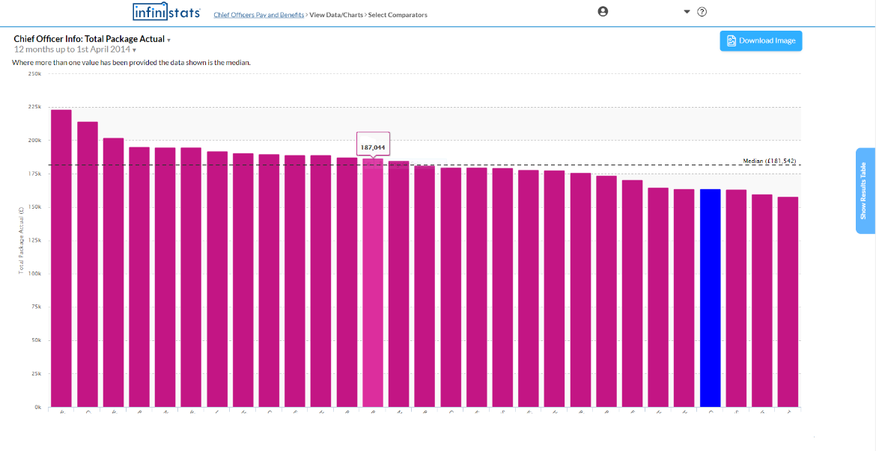

Online, you can click on Show Results Table (tab on far right) if you’d like a table too.

**To get raw data for pay surveys:**

* click on the relevant survey
* select Export Raw Data and click on Export Data

**Type 2 Surveys (online form) – eg: The Human Capital Metrics Survey**

**Entering Data – Online form**

For the Human Capital Metrics (headcount, FTE, diversity, length of service, sickness absence and leavers/turnover) survey, you enter your data onto an online form. Another survey you may be asked to complete later in the year (HR Outputs) also uses an online form.

The screenshot on the next page shows part of the online input form for the Human Capital Metrics survey. The layout/appearance of the online forms for the Human Capital Metrics and HR Outputs surveys are very similar.

* enter your response in the box to the right of each question and click on Save and Finish.
* return at any time to add or edit your data. Each time you add or edit your data click on Save and Finish.
* generate your draft survey results for checking once a minimum of 6 councils in your region have entered their data (you will see results only for metrics you have provided data for).
* your regional survey contact will also ask you for any notes on local context or unusual values, or to state if you have been unable to follow the survey guidance for a metric. These will be added to an Appendix of Notes that will appear at the end of the final reports.

**Generating Results**

The results available for the Gender Pay Gap, Human Capital Metrics surveys and HR Outputs are **Charts** (bar, trend and heatmap), full **PDF Report**, **Scorecard, Dashboards** and **Raw Data** export.

**For Charts** - select View Data/Charts and choose the Metric you want a chart for.

**For Bar Charts -** select your metric and a single period

**For Trend charts** - select your metric and beginning/end periods

and click on

Select your comparators and click on



**For Data tables** – data tables are selected from Bar Charts by clicking on Show Results Table to the right of the Bar Chart screen

**For Heatmaps** - click on



Select your comparators and click on 

**To generate a PDF report or a scorecard:**

* click on the survey you want the report for
* click on Generate/Download Outputs
* select period, PDF Report (or Scorecard) and click on **Generate Report**

This will take you to the screen to select your Metrics, and Comparators (PDF reports only – Scorecards are per region only) and generate your PDF report or your scorecard. **Some examples of PDF reports and scorecards follow** (these are headed draft until after the survey closes and the data is considered final after checks etc.)

For **Raw data** choose Export Data

The benchmark data and information provided via InfiniStats and London Councils HR Metrics Service is for the sole use of parties who subscribe to the regional benchmarking arrangements via relevant SLA and is not to be shared with third parties or other organisations outside of these subscription arrangements without the express permission of the Head of London Regional Employers’ Organisation.

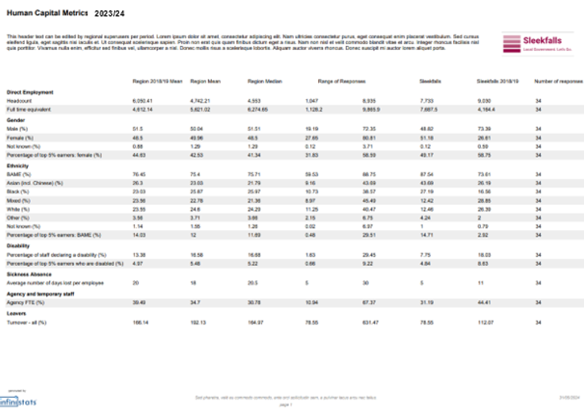

**Pulse Surveys**

Conduct your own survey of councils in your region and see/search the results of Pulse surveys that are being/have been conducted in your region. NB: Do not give or ask for any personal data in User Surveys.

**Click on Pulse Surveys:**

* you will see a list of the Pulse & User Surveys that are being/have been conducted.
* **Pulse Surveys** enable you to create multi-question surveys.
* to search the surveys by a key word click on Search.
* you can access survey results only if you have provided a response to the survey.

**To Create a New Pulse Survey:**

* select **Pulse & User Surveys** and click on + Create a new survey
* enter your survey Title (it helps to include a deadline) and Description in the onscreen boxes
* select the type of response you want to receive eg:
  + Number
  + Options (this will enable you to create a drop-down selection of up to 30 options users can choose from as their response)
  + Text – for free text replies
* click on + Add Question to add more questions to create your **Pulse survey**
* once you have set up your **Pulse survey** click on Save and Finish
* you need to answer your own survey before you can see responses from other councils

Your survey will appear on InfiniStats on the **Pulse & User** Survey screen and an email will be sent to other users notifying them of your Survey and asking them to respond.

**To Respond to Pulse**

* check Settings to ensure your Mail Preferences are set to your preferred frequency for you to receive notification of new **Pulse Surveys**, or to stop receiving Pulse Survey emails.
* click on downwards pointing arrow top right of your InfiniStats screen – choose Settings
* choose Instant, Daily, Weekly; or None (if responding to **Pulse Surveys** is not part of your role)
* click on Save Changes
* you should now receive emails about new **Pulse Surveys**
* click on the link in the email notifying you of the new **Pulse Survey**
* login to InfiniStats
* give your response
* add any comments/discussion items in the box under Discussion

**To View Results on Pulse & User Surveys:**

* click on the **Pulse Survey** you want to see the results for
* click on Results (you will only be able to see the results if you have responded to the survey)

User Guide June 2025