**How to upload your council’s DfE Assignment Data Template and summary of the General Data Template onto InfiniStats.**

InfiniStats is being used to collect a copy of the DfE Quarterly Agency CSW Pay survey to enable monitoring within region of the MoU caps.

To upload your data onto InfiniStats:

Step I – Click on the Agency CSW Pay Survey

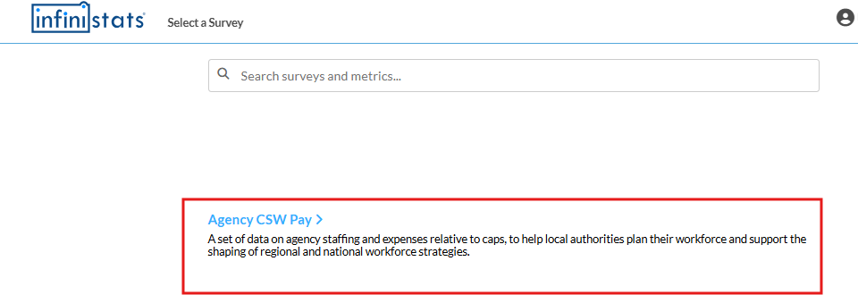

Step 2 – Click on Input / Edit Data

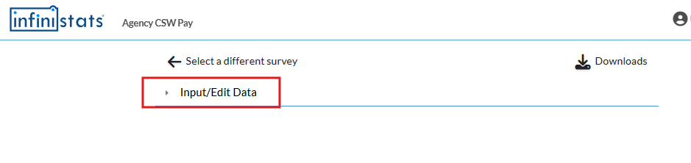

Step 3 - Click on Upload raw data

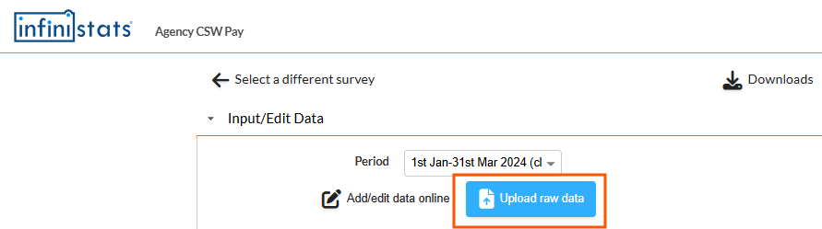

Step 4 – Click on Choose File

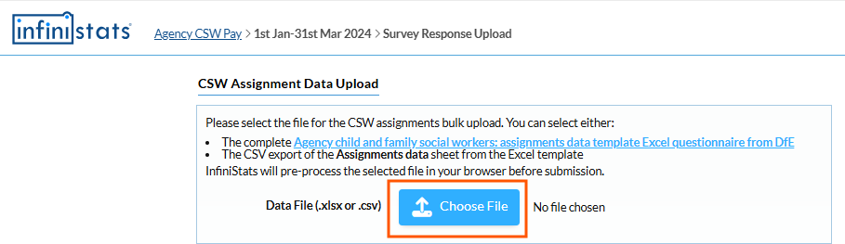

Step 5 – Your own local drive where you save your files will appear in a window. Find and Click on the Assignment Data Template you want to upload and then on Open (lower right of the window showing your local drive files).

Step 6 – You should see a summary of the first few lines of the data you’re uploading so you can determine whether you have selected the correct file. (Example below is fictitious data.) To complete the Assignment Template Upload click on Submit Data.

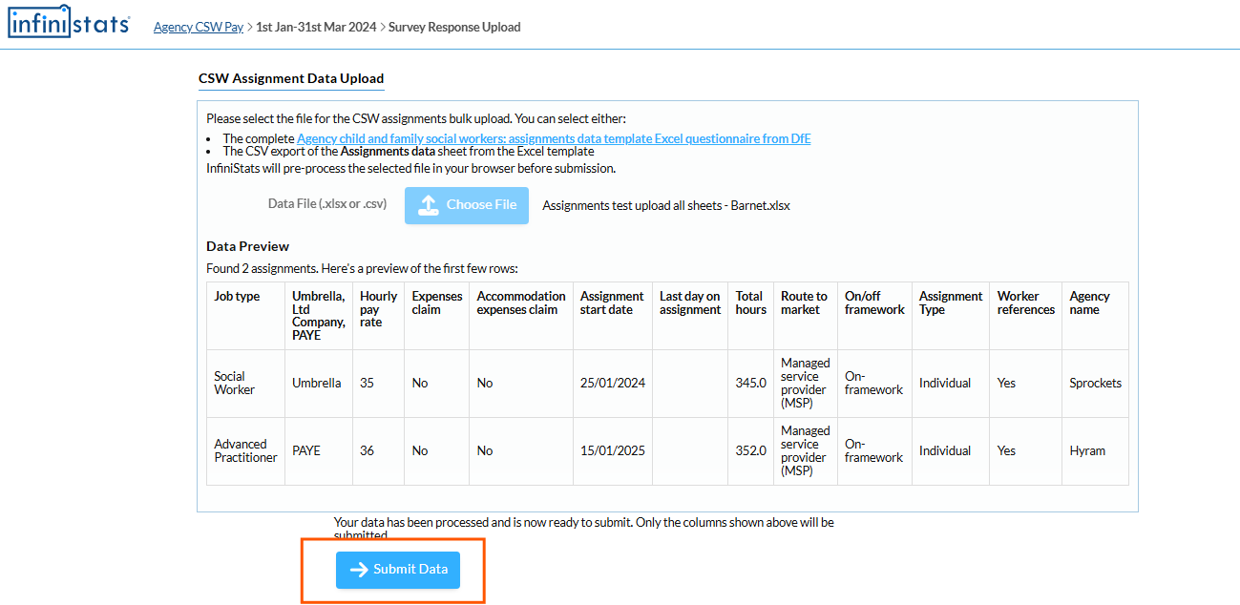

OR – if there are errors (for example a text entry like n/a in a cell requiring a value) InfiniStats will advise you of the error – click on Try again. Go to your saved file – correct the error and do the upload again. New Uploads overwrite previous uploads.

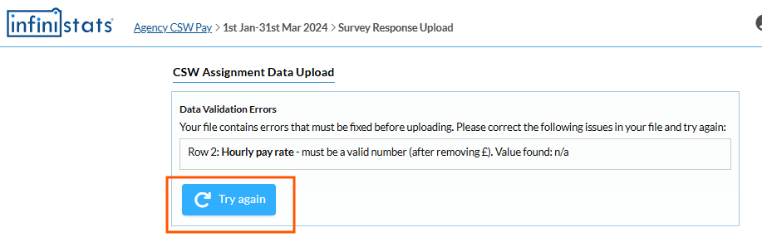

Step 7 – An online form will appear for you to enter a summary of the data from your General Picture Data Template. Complete the form. [DfE don’t require the Price caps question to be answered until a later quarter once caps have been agreed – it’s optional for you to complete on your online questions on InfiniStats but might help your region assess compliance with caps if you are willing to answer (they will also be able to tell from analysing your data whether there are over cap assignments.)] When you have completed the form click on Save and Finish.

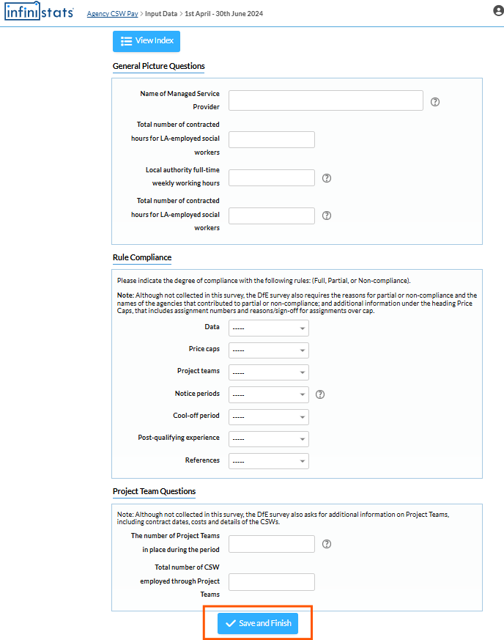

Your Upload is complete.